From Field to Data
Using UMEA Scores to Identify Performance Trends and Competitive Gaps in Marching Band Competitions
For the past four years, my daughter has participated in high school marching band. This has been a great experience for my wife and me and has exposed us to the competitive structure used by the Utah Music Educators Association (UMEA). After each competition, caption and division scores are published. This provides a transparent view of how performances are evaluated and how each performance compares to others. While these scores are publicly available, they are not presented in a way that supports complete analysis.
During the 2025 season, I recognized that the UMEA marching band website contains a treasure trove of historical data, with records dating back to 2014. At first glance, the data appeared straightforward. However, in practice, programmatic access to the data is complicated by access restrictions, layered site architecture, inconsistent table structures, and data inconsistencies across seasons. As a result, the primary challenge of this project became reliable data acquisition and transformation.
This capstone project focuses on the early stages of the data lifecycle: planning, programmatic data acquisition, and data transformation. The original goal was to complete the full data lifecycle, including analysis and visualization, within a four-week timeframe. Once the complexity of extracting the data from the UMEA website became clear, the project scope was intentionally narrowed to prioritize data acquisition and transformation.
The revised project goal is to create a structured dataset that enables analysis so band directors can identify gaps, assess performance trends, and track progress across seasons. By converting the UMEA data into a concise data format ready for analysis, a foundation is established for future analysis.
The target audience for this analysis includes high school band directors and instructional staff. Questions this dataset may help answer include:
- Which captions consistently help or hurt overall scores the most?
- How does a band’s performance compare to similar programs?
- Are observed performance changes driven by improvement over the course of a season, or are they isolated results?
- Where should instructional focus be prioritized based on historical scoring patterns?

Data Sources and Structure
The UMEA marching band data is published across multiple layers of the UMEA website, each serving a different purpose. At a high level, the site lists competitions by season and provides summary results for each performance. Detailed caption-level scores and rankings are stored on recap pages linked from those summaries.
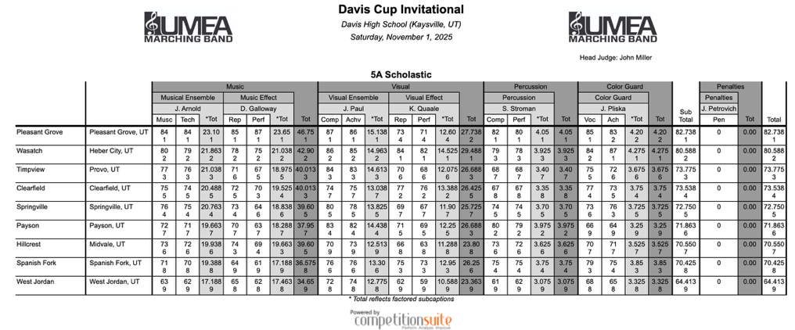
Below is an example of a recap score table.
This structure creates a natural divide between two types of data. The first is high-level metadata, including season, competition name, date, location, division, and overall score. The second is detailed recap data containing individual caption scores, rankings, and totals for each performance. Combining these two data sources is required for a meaningful analysis.

Data Acquisition Strategy
Directly scraping the UMEA marching band landing page was not possible, as the site blocks automated requests and prevents the use of standard HTML parsing techniques to build a list of competitions and recap URLs.
To work around this limitation, an API endpoint was identified by inspecting network traffic generated by the site. This API returns structured performance data for a given season, with each competition and performance identified by a Globally Unique Identifier (GUID). Accessing the API requires providing a GUID for each season, which was manually compiled into a dictionary.
The API provided reliable access to high-level performance data and recap URLs, making it the primary entry point for data acquisition. The recap pages, however, were only accessible via direct URLs, necessitating two different methods for acquiring the data.

Recap Data Extraction
While the API supplied summary data, detailed caption scores were only available on individual recap pages. These pages were accessible through standard HTTP requests and did not block automated access.
Extracting recap data presented its own challenges. The HTML structure of the recap pages relied on deeply nested tables, making extraction using simple tags selectors, such as <td>, difficult. To address this, the extraction logic used attribute-based selectors (for example, <td class="content score"> and <td class="content rank">) that target specific HTML class names associated with score and rank values. This approach was more robust and produced cleaner data.

Data Transformation and Integration:
Once extracted, recap data was transformed iteratively as issues were identified. Early outputs exposed missing fields and inconsistent formatting. Each iteration focused on resolving a specific issue before moving forward.
The final iteration produced a table where each row represents a single performance with caption-level scores, rankings, and totals. High-level metadata from the API was merged into this table to provide context, including season, competition details, division, and location. This integration step was critical. Without it, caption scores could not be analyzed across seasons, competitions, or programs.

Data Quality:
Several data quality issues were identified during extraction and transformation. First, recap table structures were inconsistent across earlier seasons, making reliable extraction prior to 2022 impractical. For this reason, the dataset was restricted to the 2022–2025 seasons.
Second, some fields, such as city and state, were missing or inconsistently represented. These fields were manually added using a lookup dictionary that maps schools to their locations.

Analysis Readiness:
The consolidated dataset is structured to support analysis but is not fully normalized. Caption scores and rankings currently exist as separate columns, which limits flexibility for visualization and statistical analysis.
To address this, the next phase of the project will reshape the data using a combination of unpivoting and repivoting techniques. This process will also separate metadata from caption data, allowing scores and rankings to be analyzed consistently across captions, performances, and seasons. Completing this step will enable clearer visualizations and support additional analytical questions without changes to the extraction pipeline.

Visualizations:
The Caption Average chart shows the average total and caption scores for Green Canyon High School across all performances in the dataset. This chart addresses the question: Which captions consistently help or hurt overall scores the most?
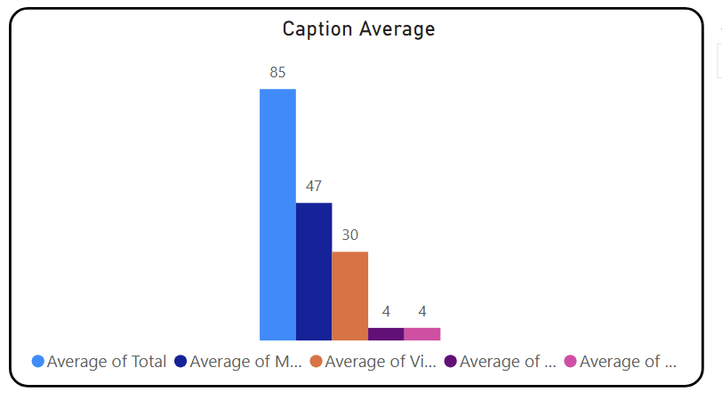
The results show that music-related captions contribute the largest share of total points, followed by visual captions, with percussion and color guard contributing substantially less. While this distribution reflects UMEA’s scoring structure, it also highlights where performance changes can impact results the most. Improvements in the music caption will have greater impact on the overall scores than equivalent improvements in lower-weighted captions.
The Average Caption Scores time-series chart shows the year-to-year average music and visual caption scores for Green Canyon High School from 2022 through 2025. Over this period average scores in both captions have remained relatively stable, with no clear upward or downward trend. This suggests a consistent level of performance in both areas, but limited year-to-year improvement.

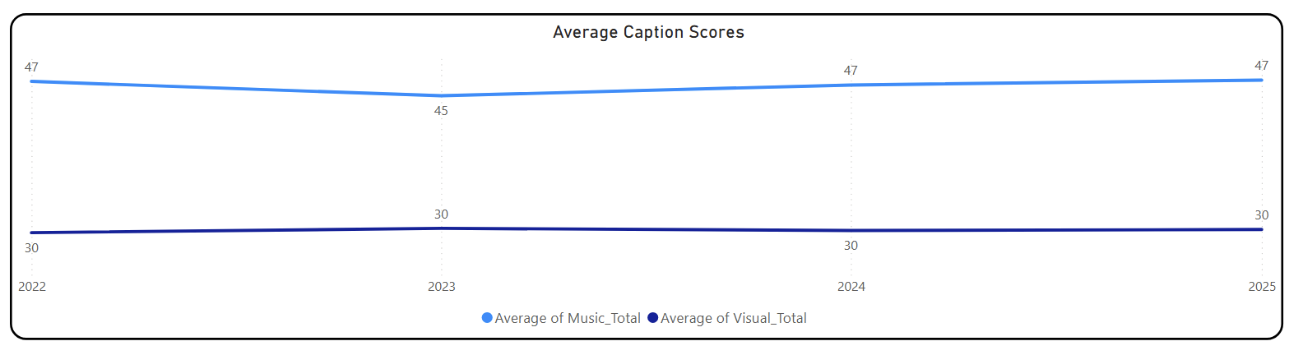
Additional gains may require changes to rehearsal strategy, instructional techniques, or program design. Together, these visuals suggest that while Green Canyon performs at a high level, future score improvements are more likely to come from targeted changes in high-impact captions, particularly music, rather than trying to improve across all caption areas.

Conclusion:
This project demonstrates that much of the work in data analytics often occurs before analysis even begins. What initially appeared to be a straightforward extraction task evolved into a complex exercise in programmatic data acquisition. HTML parsing, and data normalization. Substantial effort was required to convert UMEA marching band data into a reliable dataset ready for analysis.
The outcome of this project is a consolidated dataset containing 997 individual performances across four seasons (2022 – 2025) and 192 competition rounds. The dataset includes detailed caption-level scores and rankings, along with supporting metadata that provides context for each performance.
Tradeoffs were made intentionally. Analysis and visualization were deferred in favor of building a data pipe that is repeatable and extensible. This decision ensures that future analytical work can be performed consistently as new competition data becomes available, rather than producing a one-time analysis tied to custom extraction logic.
The resulting dataset enables analyses that are not possible using the UMEA website alone, including longitudinal performance tracking over time, caption-level trend analysis, and comparisons across programs. The data has known limitations, including variability in recap table formats and missing fields that required manual handling. These constraints required additional cleaning and limited the extraction to data after 2021.
This project reinforced an important lesson: in real analytics work, getting to the data and making it usable often matters more than how advanced or good looking the analysis appears. By first building a reliable, well-structured dataset, this work establishes a foundation for meaningful insight into marching band performance.

